**1.Granularity Mis-match:-**

Granularity is count.

Example:-

Granularity of DB is no.of tables.

Granularity of Table is no.of columns.

Granularity of Class is no.of properties.

Granularity of Application is no.of classes.

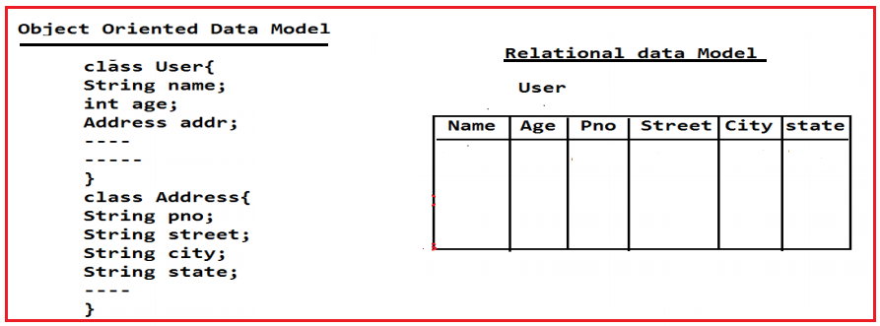

In object oriented Data model we take a class User with the properties uname, uage .. to represent an User, here if we want to represent address details of an user then we will take a separate class Address with the properties like pno,street, city ,… and we will declare Address class reference variable in User class.

In Relational Data Model we may represent a User entity and its address details in the form of single table.

From above context, the no.of classes in object oriented Data model and no.of tables in relational Data model is not matched. It reduces the Data persistency. To improve the Data persistency , we should use “Hybernate”. The hibernate provided solution to granualaity-mismatch in the form of “**component Mapping**”.